DSC 465: Extra Credit Assignment

Name: Sanchal Sunil Dhurve

I have referred to Homework 1, Question 1.a) with the Intel-1998.csv dataset and recreated an interactive visual in Shiny R.

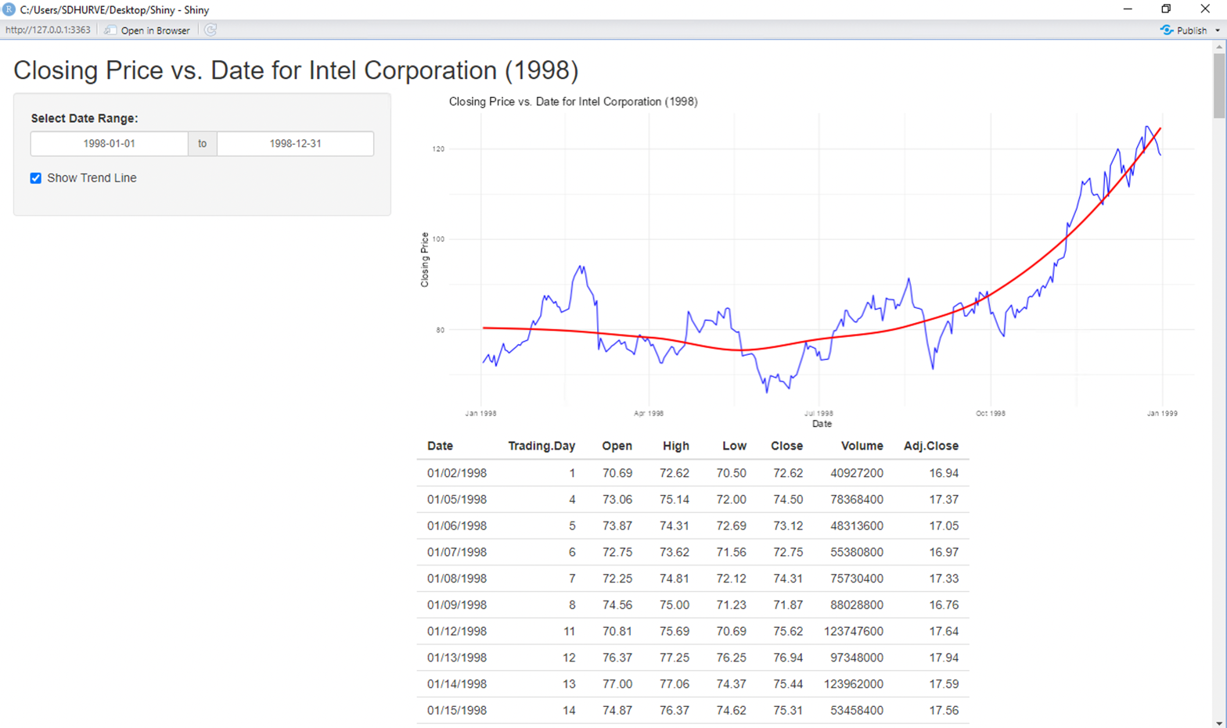

How the Visual Works and Its Benefits:
The visual uses the Intel-1998.csv dataset, which contains daily stock market data for Intel Corporation in the year 1998. It provides an interactive representation of the Closing Price vs. Date as a line graph. Users can dynamically filter the data using a date range selector to focus on specific periods and toggle a trend line to observe patterns and trends in the stock price over time. Below the graph, a table displays the filtered dataset, including details such as the opening price, highest and lowest prices, trading volume, and adjusted closing price for each day.
This interactive visualization allows users to explore the Intel stock data intuitively and gain insights into its price behavior, trends, and fluctuations during the selected timeframe. The trend line feature enhances analytical understanding by highlighting overall movement patterns, making it especially beneficial for financial analysis, decision-making, and market trend evaluation.

